**LAB7**

**DHANUSHA MALLAVAJJALA**

**TASK1**

**Frequency Analysis**

**Output-**

**TASK-2**

**So basically we will use different types of encryptions**

**1.CFB:-**

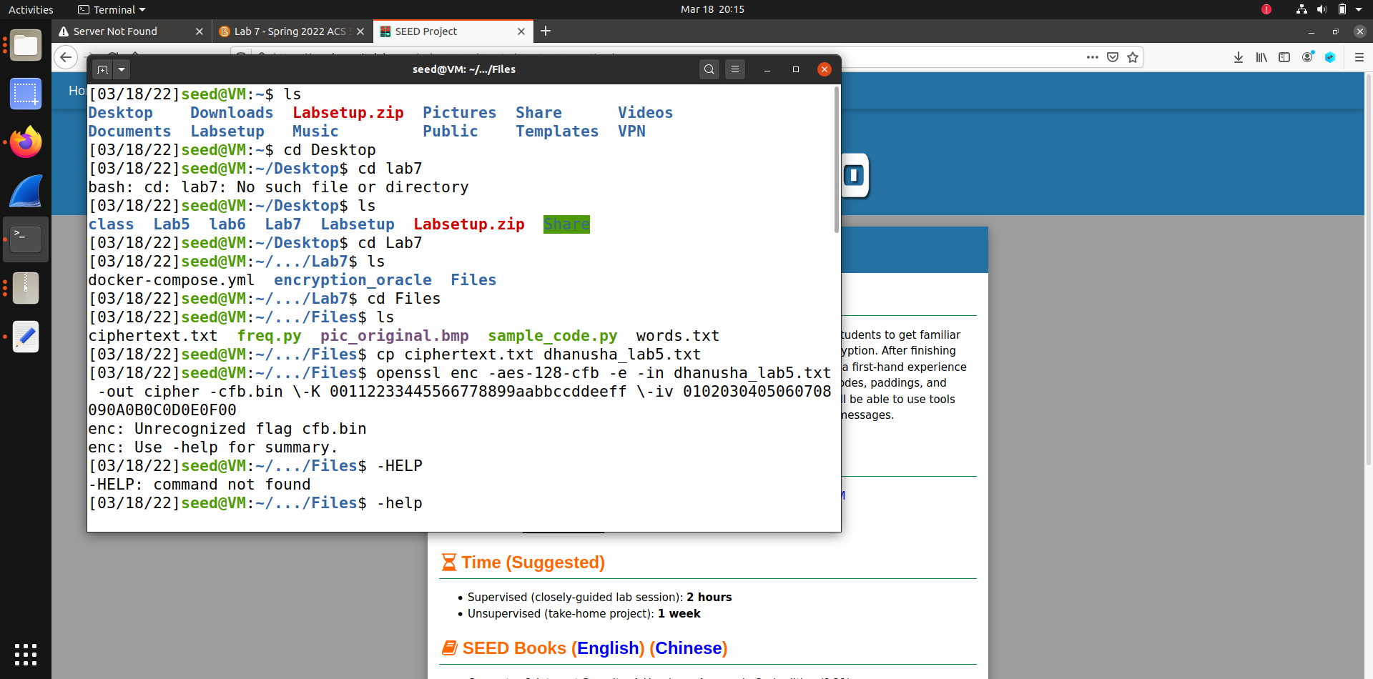



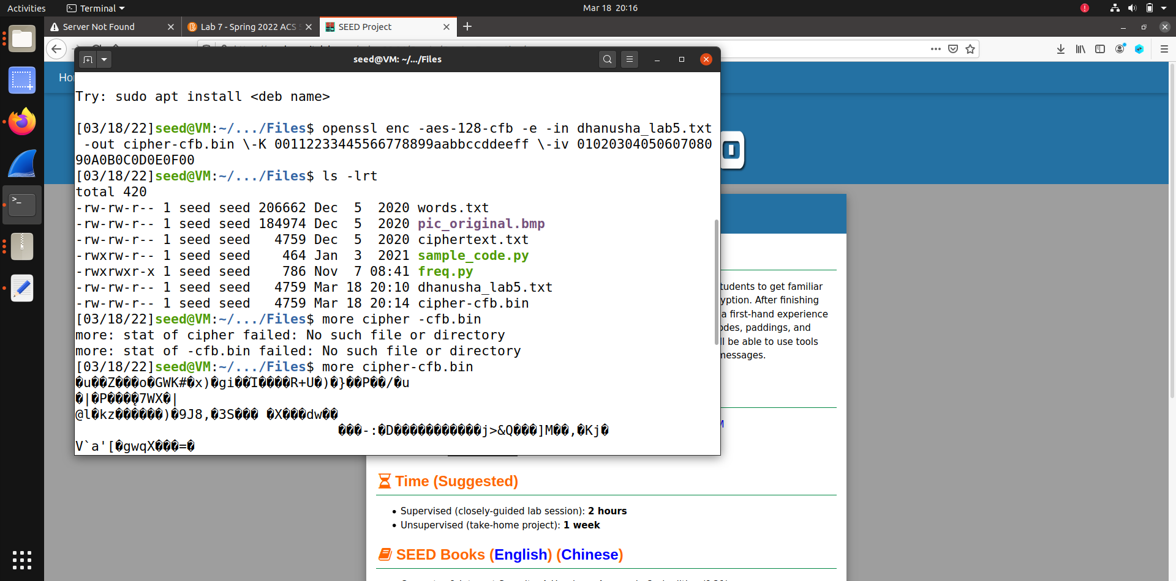



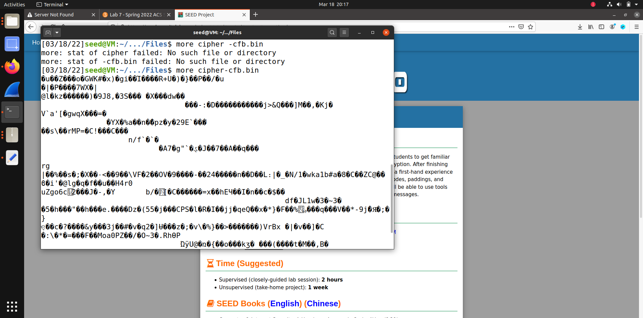

**2.Encryption with CBC-**

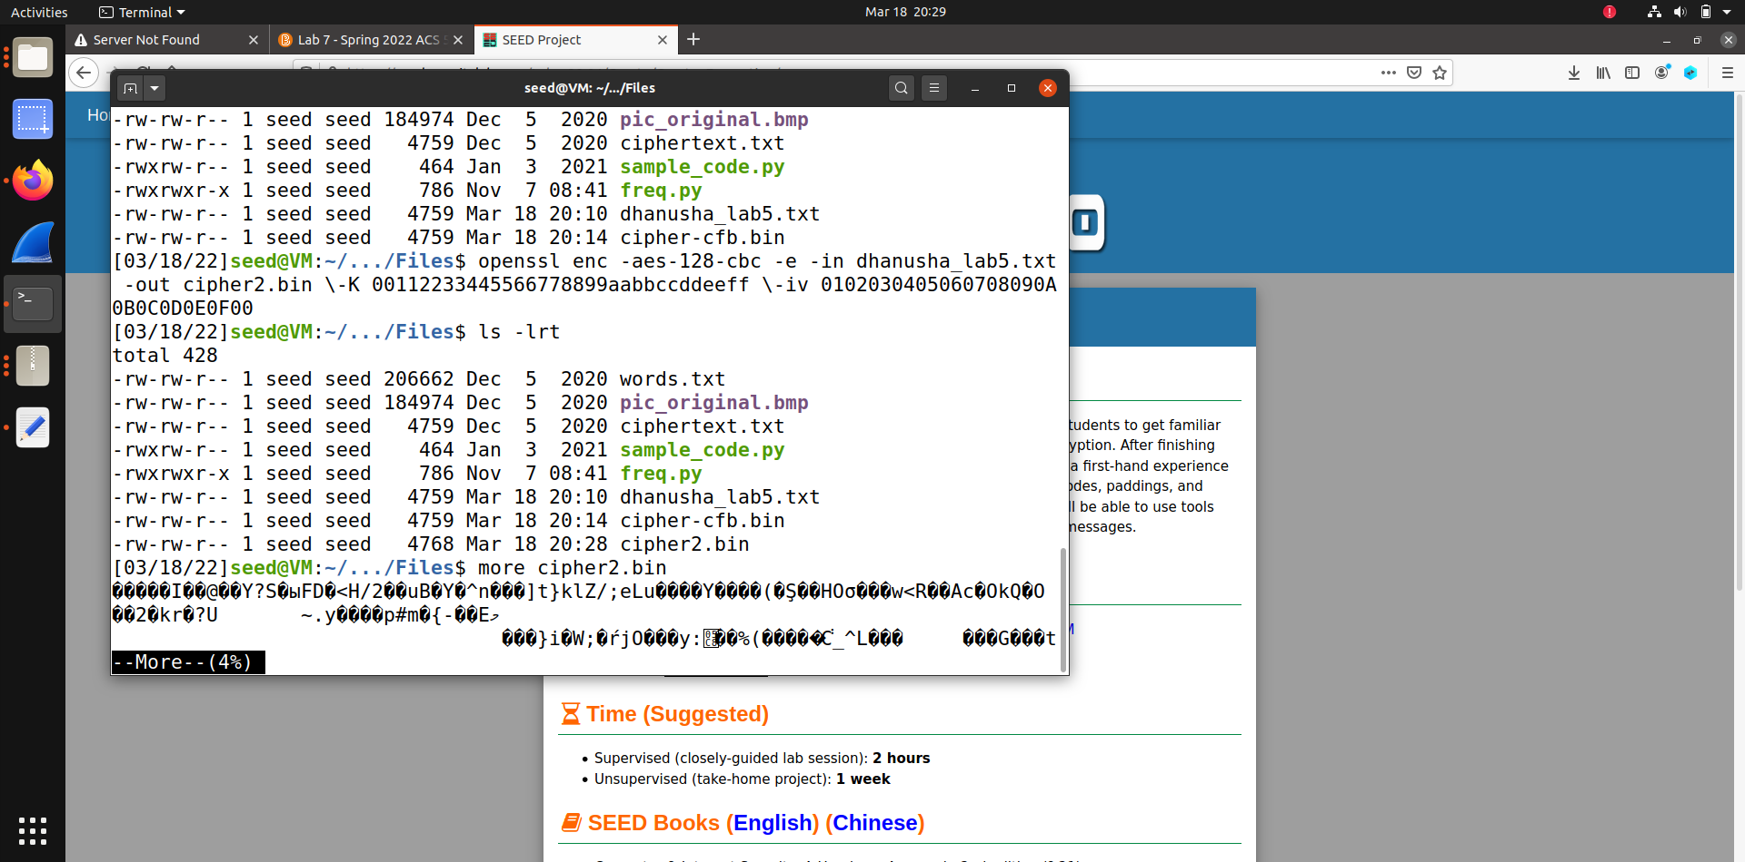



3**. Encryption using OFB-**

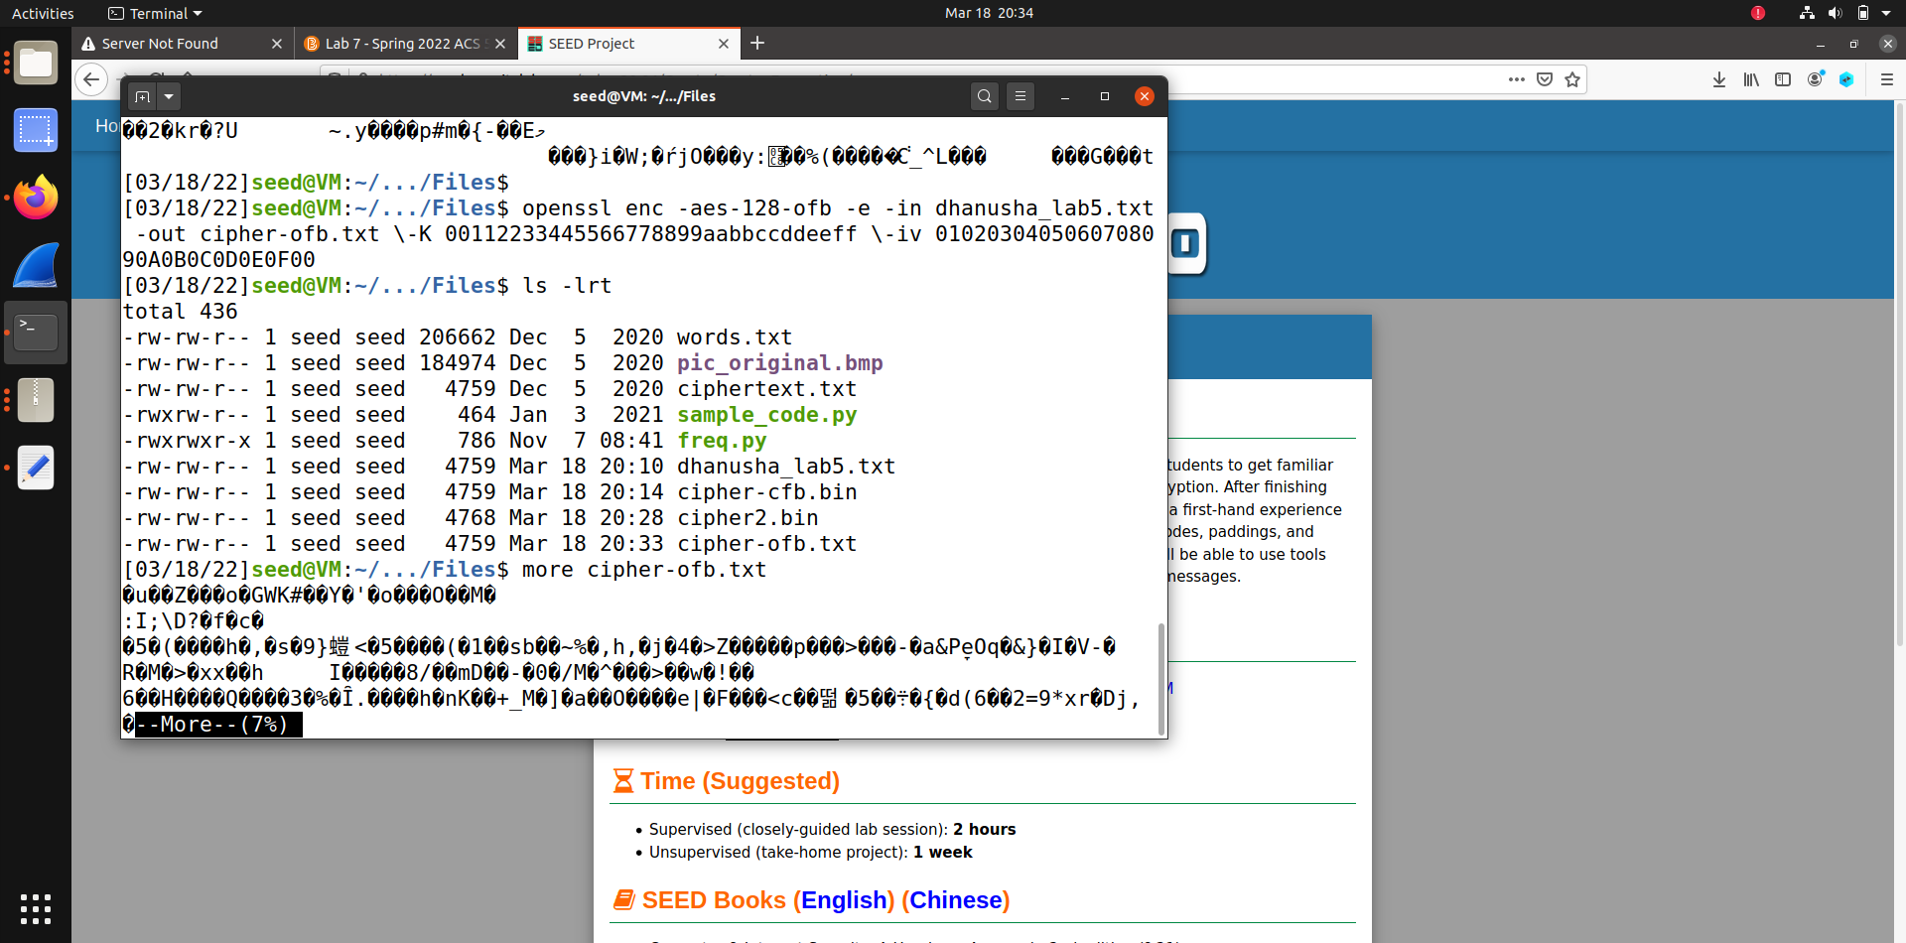



4. **Encryption using ECB-**

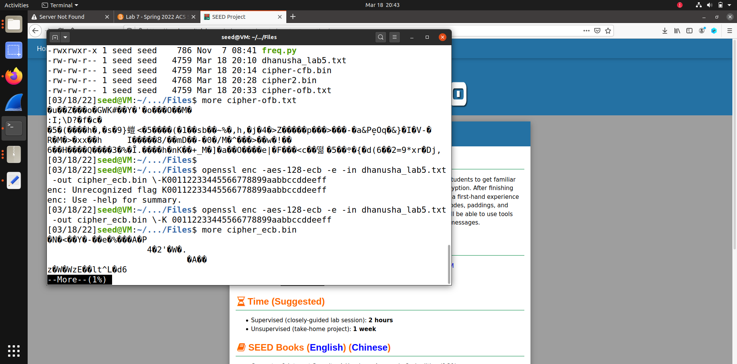



5.**Encryption with Blowfish-**

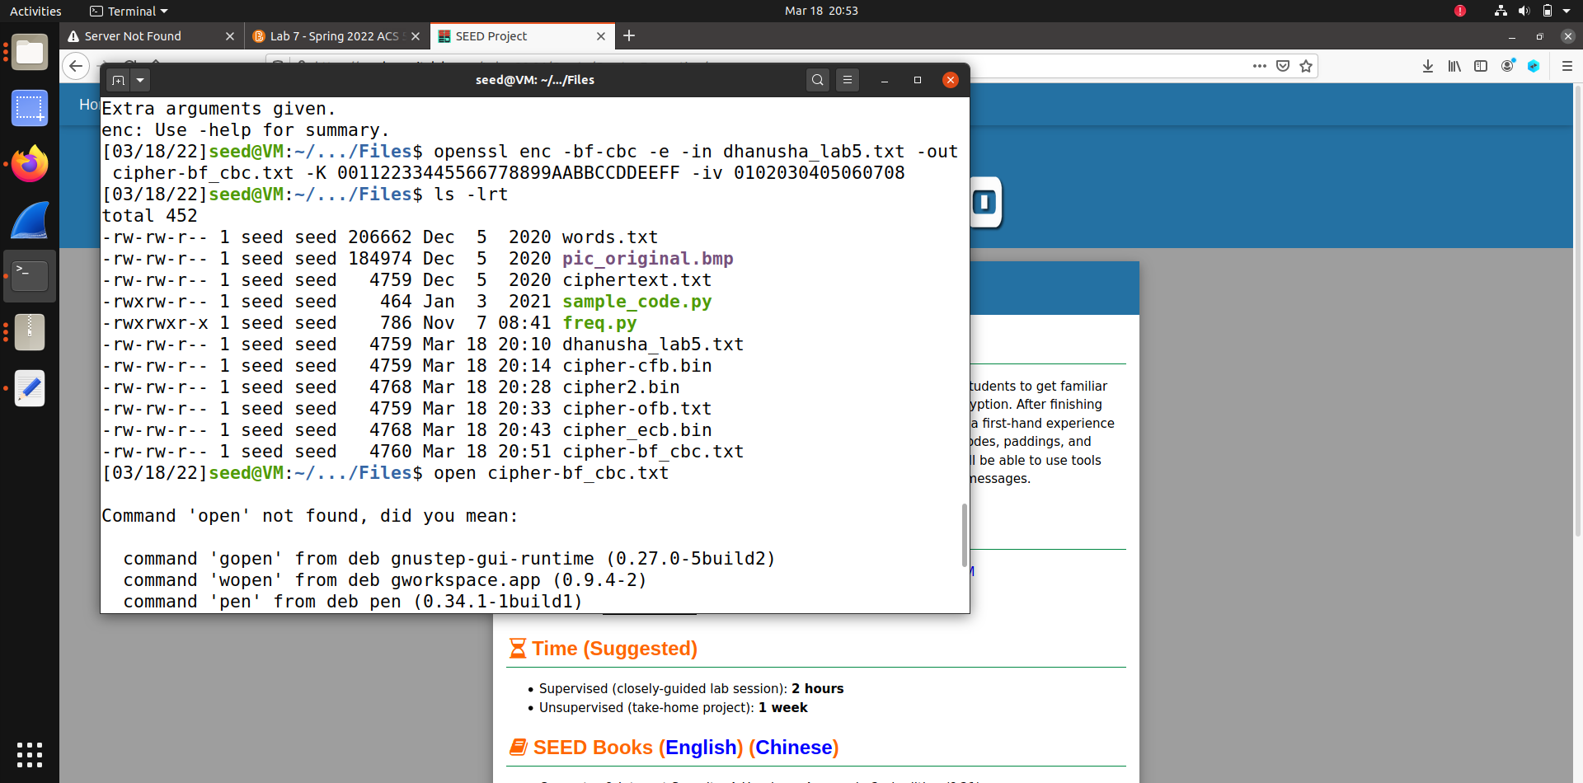



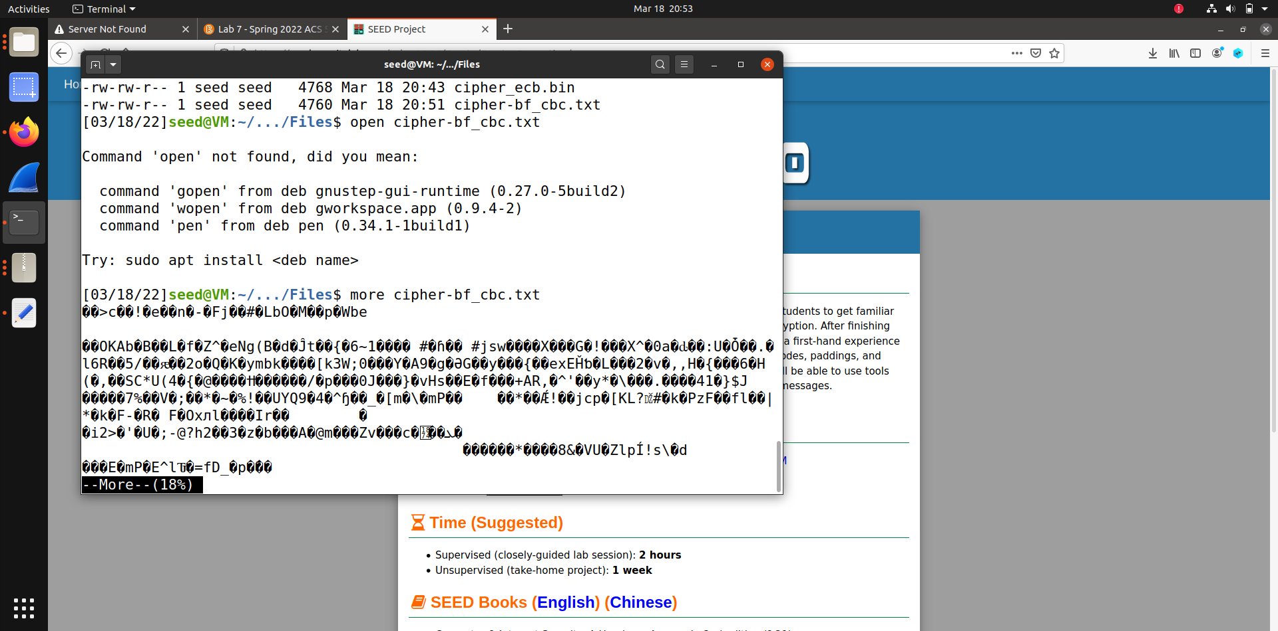



TASK-6

**6.1Two different IVs**

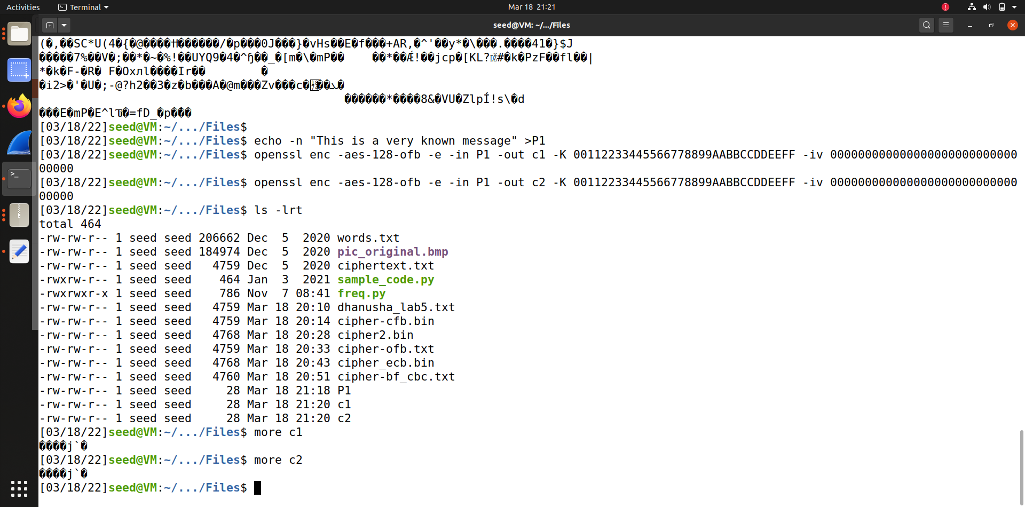



Using same IV on P1&P2

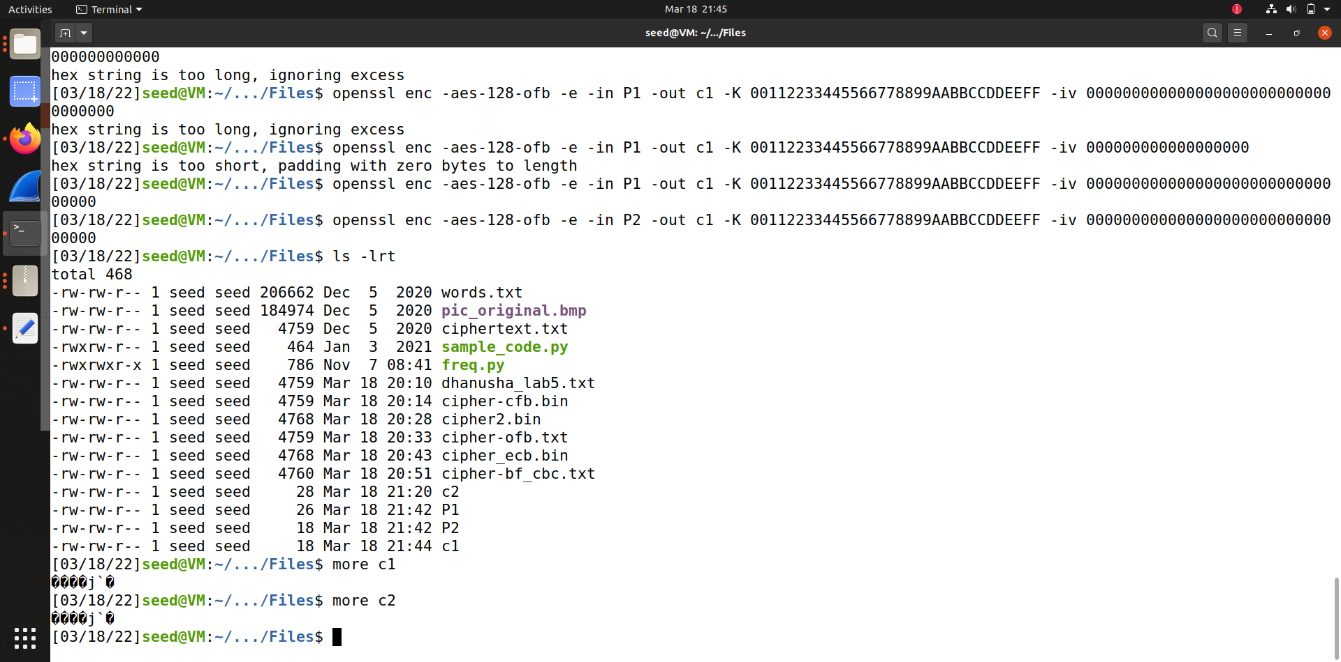



Now with different IVs

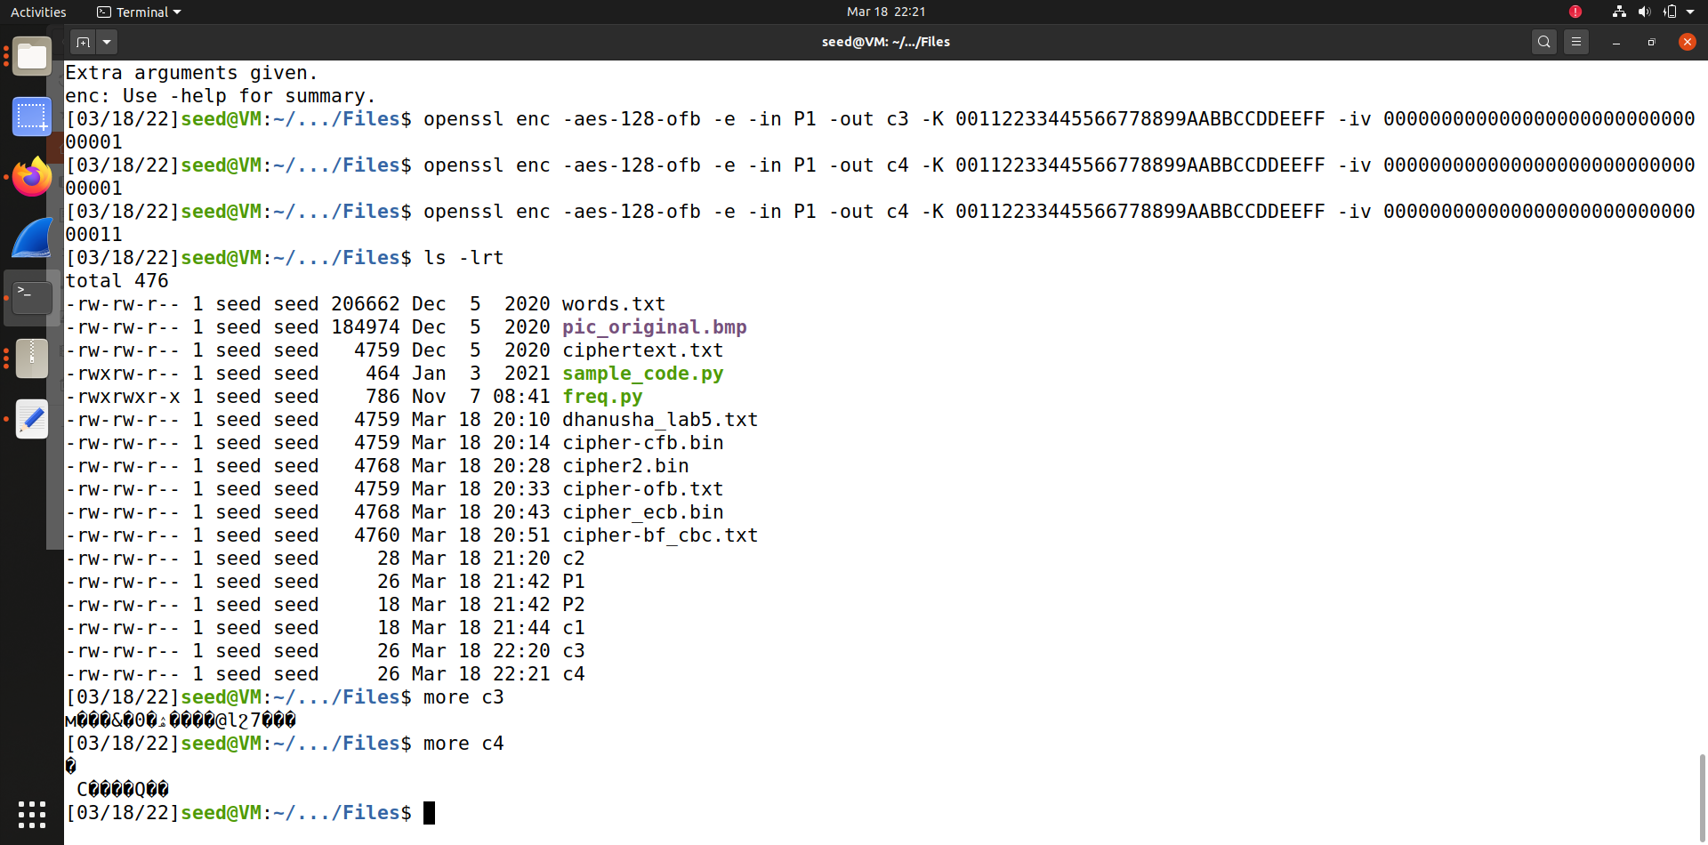



**Task 6.2-**

**So I used xor file which prof has given in brightspace**

**Task 6.3**

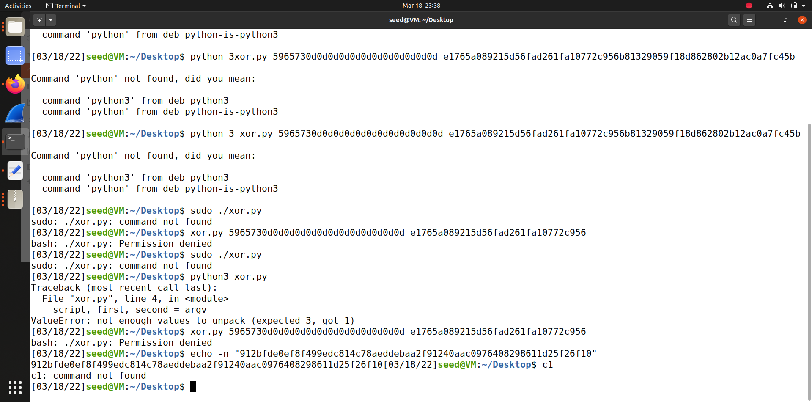

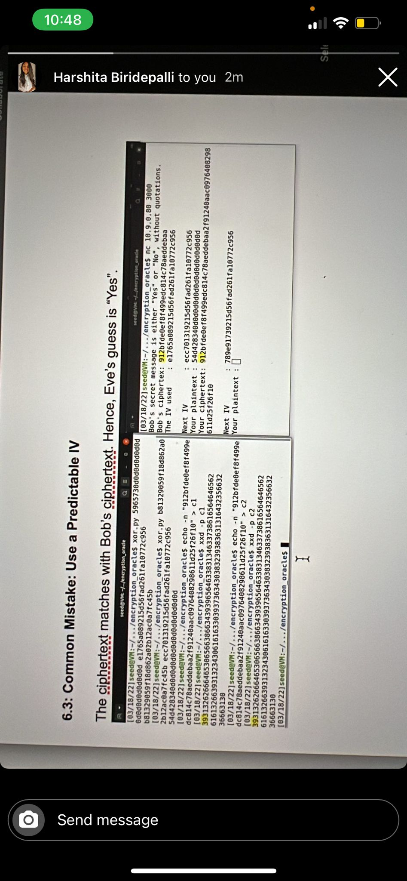



**Task 7-**

